**FYP-1 Midterm Evaluation Report**

**MarkAid: An Intelligent Learning Platform**

**F22-064-D-MarkAid**



**Group Members:**

Zuraiz Zahoor Ajaz(19I-1793)

Gulam Mustafa Imran (19I-1776)

Syed Bilal Ahmed (19I-1874)

**Department:** BS (AI)

**Approved by:**

Dr. Omer Beg

**Table Of Contents**

**Introduction** **3**

**Project Vision** **4**

Problem Statement 4

Business Opportunity 5

Goals 6

Project Scope 6

Constraints 7

Stakeholders’s Description 7

Stakeholders Summary 7

Key High Levels Goals and Problems of Stakeholders 7

**Product Features** **8**

**Use Cases** **9**

Use Case Diagram 9

High Level Use Cases 9

Expanded Use Cases (Iteration-1) 12

Domain Model 17

**System Sequence Diagram** **18**

Essay Grading 18

Generating Quiz 19

Student/Teacher Analytics 20

Student/Teacher Feedback 20

Q/Answering System 21

Exam AutoGrading 22

**Activity Diagram** **22**

Auto Grading 23

Intelligent Question/Answering 24

**Architectural Diagram** **25**

**Data Flow Diagram** **25**

Web Page Flow 25

Backend Flow 26

**Wireframing** **26**

**Conclusion** **27**

**References** **27**

# **Introduction**

As AI-based applications such as natural language processing (NLP) and Machine Learning (ML) become increasingly popular, the impact of AI is being felt across different industries. According to various statistics, the global market for artificial intelligence is expected to proliferate but industries like education have still not experienced the peak potential of AI.

The use of technology has been observed in the education sector as we can observe numerous learning platforms which have no doubt resulted in increased collaboration, efficiency and productivity. A learning platform is an integrated set of interactive online services that equips teachers, students or parents with informative tools and resources to enhance the quality of education. The ultimate goal of a learning platform is to improve educational management or delivery.

Our proposed learning platform would include the ability to auto-grade assessments, quizzes/assessments conduction, intelligent feedback analysis that will allow teachers and students to identify their weak areas, a smart question-answering agent that would help students to extract answers from various passages, and effective visualization in the form of dashboards. These modules would enhance the productive capability of the learning platform and would make it superior to the existing solutions.

# **Project Vision**

## **Problem Statement**

While a number of platforms have been developed in recent years, such as Google Classroom[2] and Piazza[3] which are doing a great job enhancing the productivity and collaboration of both students and the teachers, a number of limitations still exist. If we take a deeper look into these learning platforms, we will be able to identify the dire requirement of tools such as automated marking, creation/generation of assessments, self-evaluation or other smart in-depth analytics for student's progress as they are either missing in major learning platforms or are not collectively combined and delivered as a single solution.

One major limitation of the existing learning platforms is that due to current functionalities incorporated in them they are merely used to make announcements or to collect assignments by the teacher. Such learning platforms are not efficiently enhancing productivity at a high level. Furthermore, such platforms are increasing the load of operational tasks on the teachers rather than reducing it as now the teacher has to open submissions just for the sake of getting them at one place. Such platforms are able to collect assessments/tasks submitted by students but lack the functionality of an incorporated auto grader which can assist teachers in grading students or an assessment/quiz generation module which would let the instructor worry less about the operational tasks and would utilize that time in other important tasks.

Another limitation of the existing learning platforms is that the students are enrolled in a course cannot keep track of their performance as firstly only handpicked solutions have the option for the teacher to mark the students and return assessments and secondly student performance is not recorded which makes it impossible for the teacher to keep track of weak students in a class. It also makes it difficult for students to recognize the concepts they need to work on and the subjects they need to put extra effort in.

A complete solution addressing the above listed challenges and limitations would be highly beneficial to institutions and teachers in improving the quality of education by smartly assisting both the teachers and students, reducing the load of operational tasks from teachers as well as giving them a clearer picture of the progress of their students, thus allowing them to make informed decisions.

## 

## **Business Opportunity**

Intelligent Learning Platforms have a huge potential in the world today. According to [International Computer and literacy study [1]](https://nces.ed.gov/surveys/icils/icils2018/theme1.asp), 86% of 8th-grade teachers agreed that using technology to teach students is important and according to a study conducted in the United States more than 75% of teachers agree that online education is both more productive and helpful for students to perform better. If we observe the post Covid-19 era, we can see how a lot of institutions have gotten comfortable with online education. The global EdTech market size was valued at 106.46 billion in 2021 and is expected to reach USD 605.40 billion by 2027.

EdTech is growing at an exponentially fast pace as more than 70% of institutes are expected to launch one or more online undergraduate programs in the next three years, thus it has now become crucial for institutions to invest into technological solutions for improving their education standards. According to a study conducted recently a Teacher spends more than 50% of his/her time performing operational tasks such as grading or creating assessments, this creates a huge market for intelligent learning platforms which efficiently reduce this time expenditure.

Keeping the above figures in view, EdTech solutions or Learning Platforms have potential room for growth in the future. As such, MarkAid will be used by different institutions including but not limited to Schools, Colleges, Universities, and other Academic Institutions. It will be an efficient platform to be used by Teachers and Students which will be providing them with relevant tools to promote efficient educational standards and productivity, combined with a collaborative environment to improve educational experience and increase collaboration between students and teachers. Teachers would thus be able to make informed decisions regarding the curriculum of their subject and take the necessary actions required to help weak students.

## 

## **Goals**

Our proposed learning platform, MarkAid would be meeting the following goals:

1. Overcome the above-listed challenges
2. Intelligent policy-based grading and analysis
3. Providing an environment that boosts productivity
4. Have an intuitive user interface that effectively communicates relevant intelligence

## **Project Scope**

MarkAid would be providing a seamless interface for the teachers and students to collaborate in a better way. It would have specific modules dealing with grading, analysis, self assessment, study planning and intelligent answer extraction. Moreover, MarkAid would only be providing intelligent policy based grading for theoretical subjects like World History, Pak Studies, Islamiat and not for conceptual subjects like Physics, Mathematics or Chemistry.

## **Constraints**

One of the major constraints is the massive GPU consumption required to train, test and fine tune the latest NLP state of the art models. Another constraint is the dataset of actual answers of students which will improve the quality of grading.

## **Stakeholders’s Description**

### **Stakeholders Summary**

MarkAid will be an efficient platform to be used by Teachers and Students.

**Teachers:** Will be using the efficient modules presented by MarkAid in order to mark/grade student's assessments and analyze the performance of the students which frees up hours that teachers usually spend grading assignments. This free time for teachers will provide more flexibility for one-on-one time with both struggling and gifted students.

**Students:** Will be the primary users of MarkAid. They will be able to analyze their progress throughout the course and identify their weak areas. Students will be able to use the auto-assessment module to practice for their exams. Students may also take advantage of the smart QnA agent in the application to cut down the hassle of skimming through passages to get the right answer.

### **Key High Levels Goals and Problems of Stakeholders**

* **Teachers:**
* **High Level Goal:** Using auto assessment scoring modules to automate checking of relevant subjects.
* **Problem:** A lot of time consumed in grading students' assessments individually
* **High Level Goal:** Comprehensive reports regarding students' performance
* **Problem:** Struggle to identify need for extra attention to week students due to lack of high-level reports outlining student portfolio and performance
* **Students:**
* **High Level Goal:** A centralized platform to observe and track performance and utilize intelligent AI-based modules to enhance productivity
* **Problem:** Students struggle keeping track of their performance throughout the course.

# 

# **Product Features**

MarkAid’s features will include:

1. To create an efficient solution that auto grades subjective answers for subjects like Islamiat/Pak Studies, World History
2. To create a platform that would allow teachers to conduct online assessments that would be graded automatically based on the policies or schemes provided by the teacher as well as let them upload attempted student solutions and get them graded too.
3. Create a dashboard for teachers and students in order to maintain analytical statistics on both ends.
4. Smart question answering.
5. Feedback sentiment analysis on both students and teachers ends.
6. Community Platform integration (ideally using Circle.io API) for teachers and students to interact.

# **Use Cases**

## **Use Case Diagram**

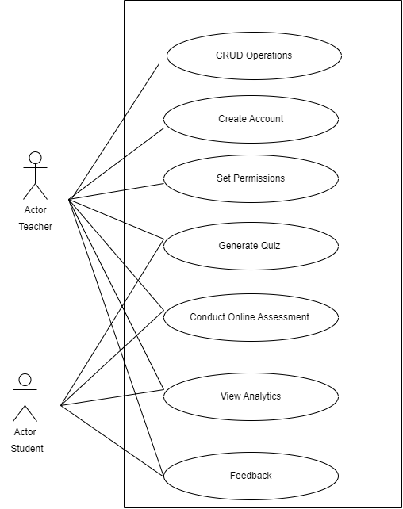

## **High Level Use Cases**

## 

| Use Case Name | Quiz Generation |
| --- | --- |
| Actors | Teacher |
| Type | Primary |
| Description | The Teacher should be able to generate assessments or quizzes by providing a passage or text to the system. |

| Use Case Name | View Individual Student Performance Visualization |
| --- | --- |
| Actors | Teacher |
| Type | Primary |
| Description | The Teacher should be able to view visual structures that represent the individual performance of enrolled students in the particular course taught by the teacher. |

| Use Case Name | View Student Performance Visualization |
| --- | --- |
| Actors | Student |
| Type | Primary |
| Description | The Student should be able to view visual structures in the form of dashboards that represents his/her performance throughout the course. |

| Use Case Name | CRUD Operations for Material |
| --- | --- |
| Actors | Teacher |
| Type | Primary |
| Description | The Teacher should be able to perform CRUD operations such as Insert, Delete, Update, and View information about the material of the course that include things like assessments, assignments, notes, lectures etc. |

| Use Case Name | Operations on Enrolled Students |
| --- | --- |
| Actors | Teacher |
| Type | Primary |
| Description | The Teacher should be able to Add, Delete View information about the Students enrolled in the course. |

| Use Case Name | View Statistical Analysis of Student Data |
| --- | --- |
| Actors | Teacher |
| Type | Primary |
| Description | The Teacher should be able to view statistical analysis in the form of charts and figures to display information based on student performance, average class performance, concepts bothering students, weak students, top performers, etc. on the Dashboard. |

| Use Case Name | Giving Feedback |
| --- | --- |
| Actors | Teacher and Student |
| Type | Primary |
| Description | Both the Teacher and Student should be able to give feedback to each other in order to highlight any queries or core points. |

| Use Case Name | Auto Essay Scoring Module |
| --- | --- |
| Actors | Teacher & Student |
| Type | Primary |
| Description | Both the Teacher and Student should have access to the AES module; the teachers utilizing it to mark submitted essay-based assessments with complete autonomy over the final grading and getting complete insights while the students using it for self-evaluation with restricted insights and control over it. |

| Use Case Name | Smart Question & Answering Module |
| --- | --- |
| Actors | Student |
| Type | Primary |
| Description | The Student should be able to use the Smart QnA module and query it to extract to the point information from the long passage or text provided by the Student. |

| Use Case Name | Auto Grading Subjective Questions |
| --- | --- |
| Actors | Teacher & Student |
| Type | Primary |
| Description | Both the Teacher and Student should have access to the subjective question auto grading module; the teachers utilizing it to mark submitted assessments over a given policy with complete autonomy over the final grading and getting complete insights while the students using it for self-evaluation with restricted insights and control over it. |

| Use Case Name | Sign In |
| --- | --- |
| Actors | Teacher & Student |
| Type | Primary |
| Description | Both the Teacher and Student should be able to Sign in to their account and maintain a session for as long as they are active. Sign in should include user authentication as well. |

## 

## 

## **Expanded Use Cases (Iteration-1)**

## 

| Use Case Name | Sign In | |
| --- | --- | --- |
| Scope | MarkAid-An Intelligent Learning platform | |
| Level | User-Level | |
| Primary Actor(s) | Student | |
| Stakeholders | Student: Wants to be able to create an account on the application easily, swiftly and with minimum inconveniences. | |
| Pre-Conditions | 1. Student has an existing email address. 2. Student has opened the application. | |
| Success Guarantee | System will log in the user and display the welcome message. | |
| Main Success Scenario | Actor Action   1. Student opens the website.       3. Student enters their username and password      5. Student clicks on “Sign In” button. | System Responsibility     1. System displays the Sign In page.       4. System checks the validity of username and password.      6. System verifies with the database if the username exists    7. System verifies the password entered with the one stored in the database against the username.      8. System shows the dashboard to the user. |
|  | 3a. Student enters wrong password.   1. System signals error to Customer. 2. Customer re-enters password.   3c. Customer enters a code (SQL Injection).   1. System signals error/Warning Customer. 2. Customer re-enters username/password.   4a. The Username has invalid characters   1. System signals error/Warning Customer. 2. Customer re-enters username.   6a. Username does not exist.   1. System signals error Customer. 2. Customer re-enters username. | |
| Special Requirements | If there are more than three wrong attempts in signing in, then send a warning email to the owner of the account. | |
| Technology and Data Variations List | Active Internet connection | |
| Frequency of Occurrence | Happens whenever user accesses the system. | |
| Open Issues |  | |

## 

| Use Case Name | AES Module | |
| --- | --- | --- |
| Scope | MarkAid-An Intelligent Learning platform | |
| Level | User-Level | |
| Primary Actor(s) | Student | |
| Stakeholders | Student: Wants to be able to get his/her Essay graded by the AES Module. | |
| Pre-Conditions | 1. Student has logged in successfully into his/her account. 2. Student has provided the Problem Statement (Question) against which he/she has written the essay. | |
| Success Guarantee | System takes in the attempt and displays the score the student has received. | |
| Main Success Scenario | Actor Action   1. Student clicks the practice essay tab.       3. Student enters the question and attempted essay      5. Student clicks on “Mark Me” button. | System Responsibility     1. System displays the AES Module page.       4. System initially checks the validity of question and answer by performing some checks      6. System feeds the relevant information to the AES model and gets its prediction    7. System displays the prediction returned by the model. |
| Special Requirements | The essay must be of some specified length and in English language. | |
| Technology and Data Variations List | Active Internet connection | |
| Frequency of Occurrence | Happens whenever user wants it to. | |
| Open Issues |  | |

## 

## 

## **Domain Model**

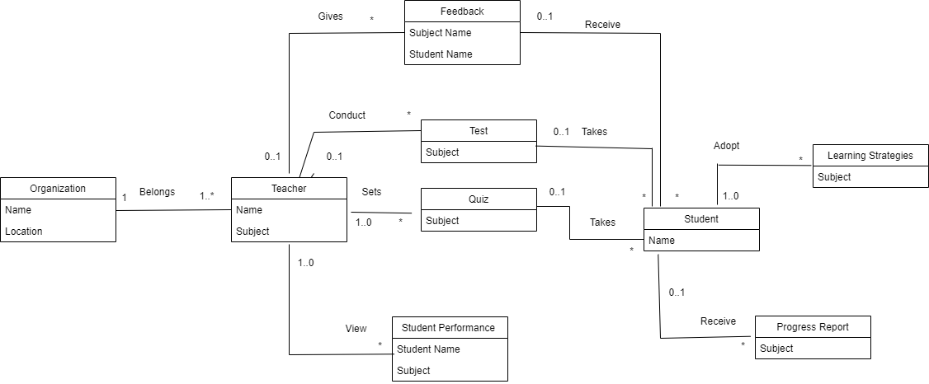

# **System Sequence Diagram**

### **Essay Grading**

# 

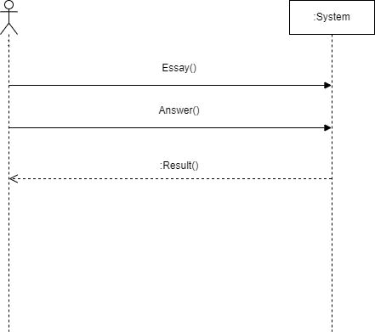

### 

### 

### 

### 

### 

### 

### **Generating Quiz**

# 

### **Student/Teacher Analytics**

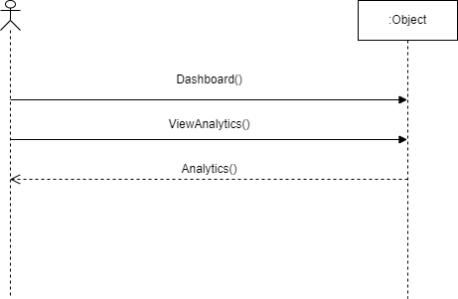

### 

### **Student/Teacher Feedback**

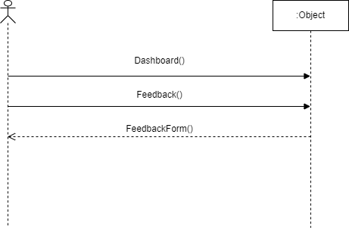

### **Q/Answering System**

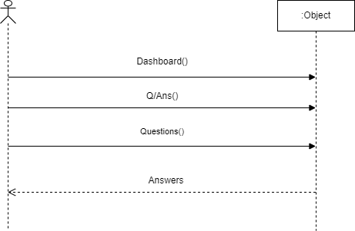

### 

### 

### **Exam AutoGrading**

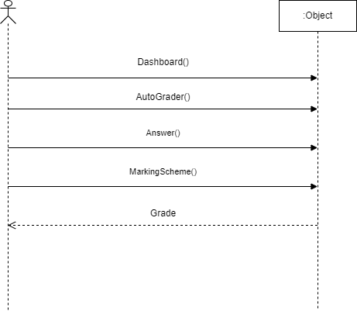

# 

# 

# 

# Activity Diagram

### Auto Grading

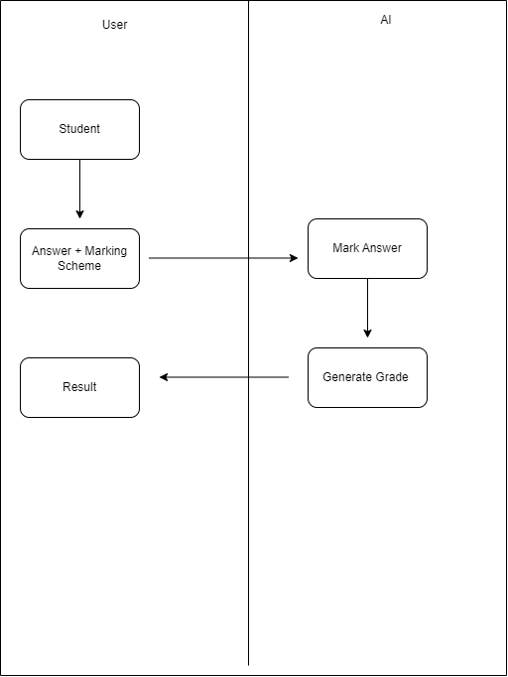

Intelligent Question/Answering

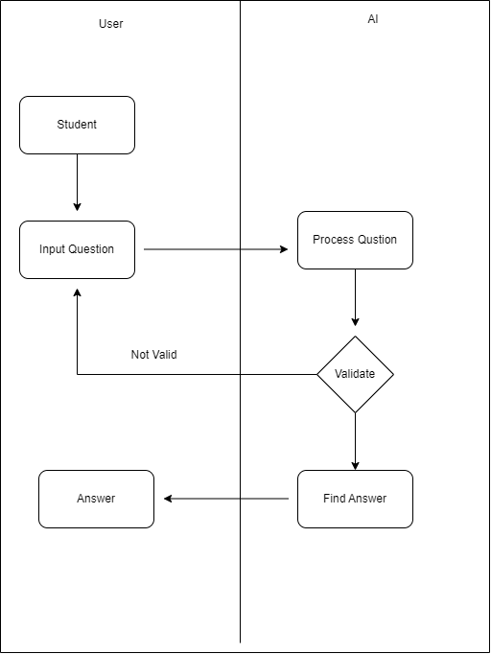

# **Architectural Diagram**

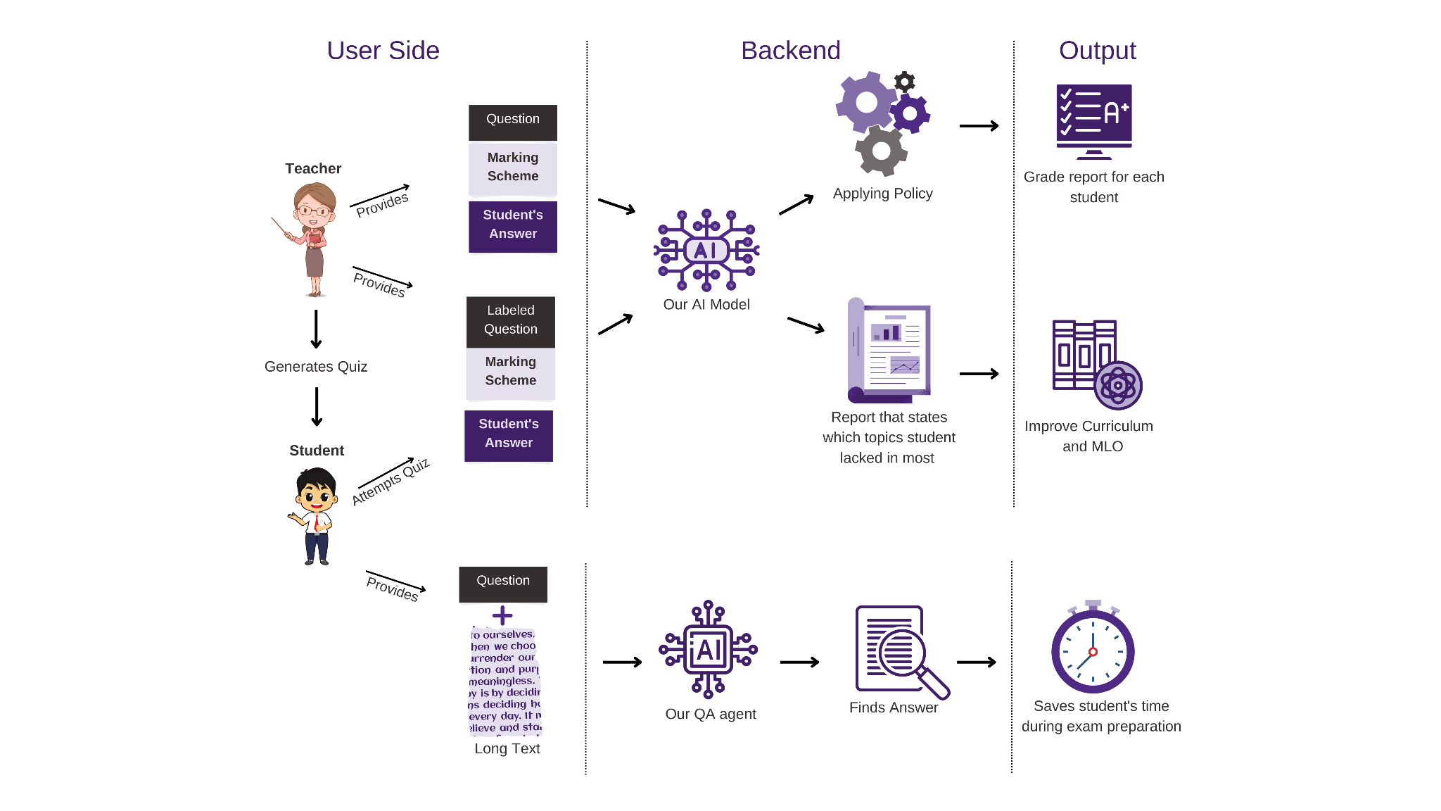

# **Data Flow Diagram**

### Web Page Flow

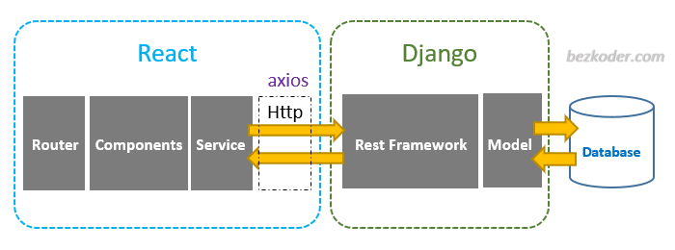

### Backend Flow

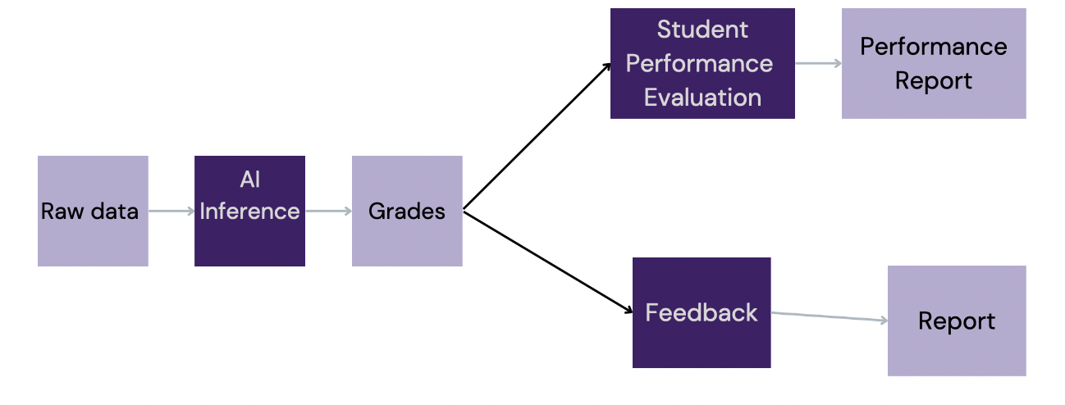

# **Wireframing**

**Creating Exam**

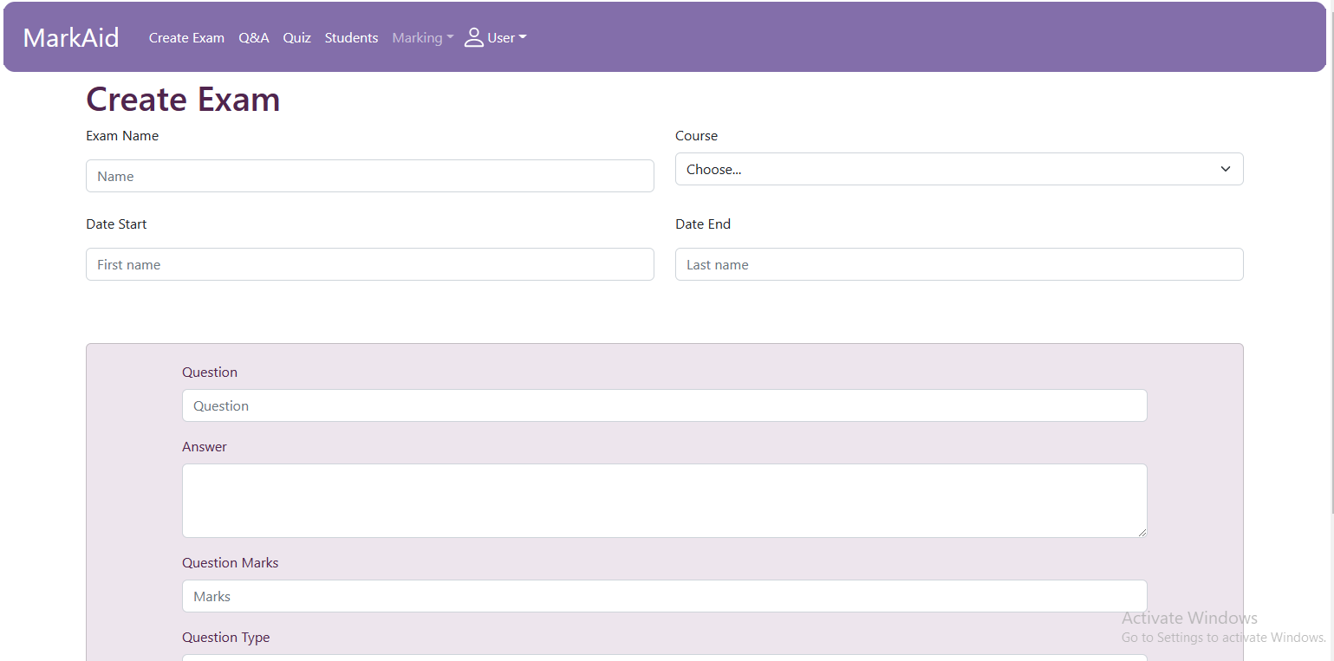

**Intelligent Q/Ans System**

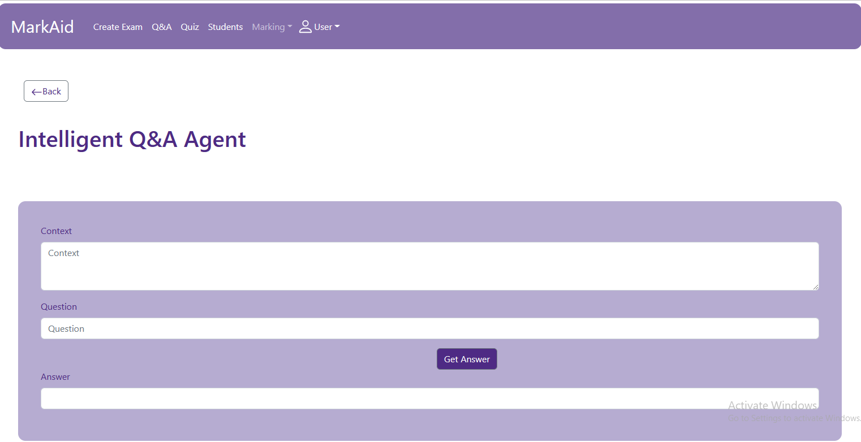

**Quiz Genration**

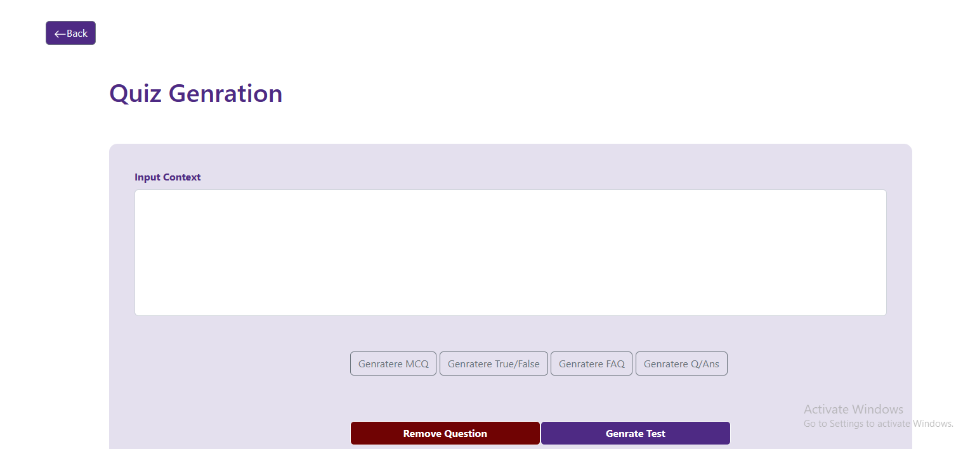

**Students Enrolled**

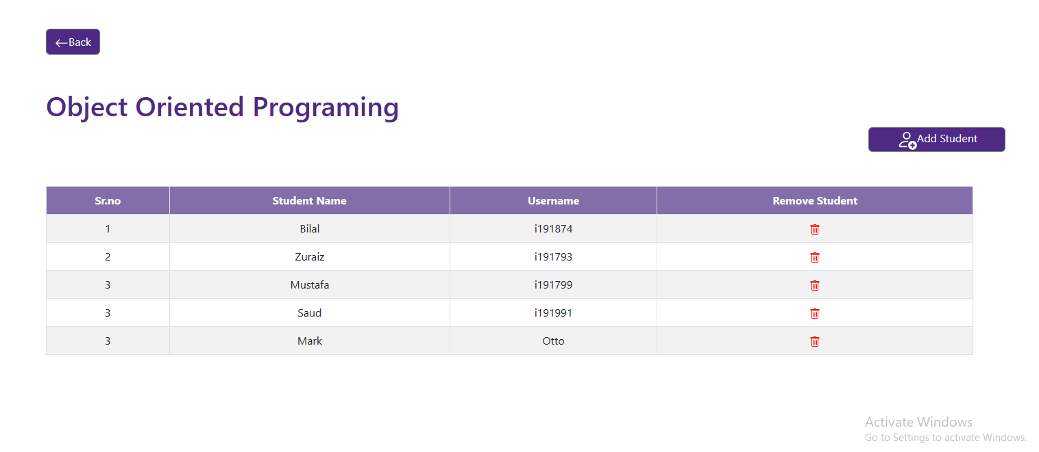

**Essay Grading**

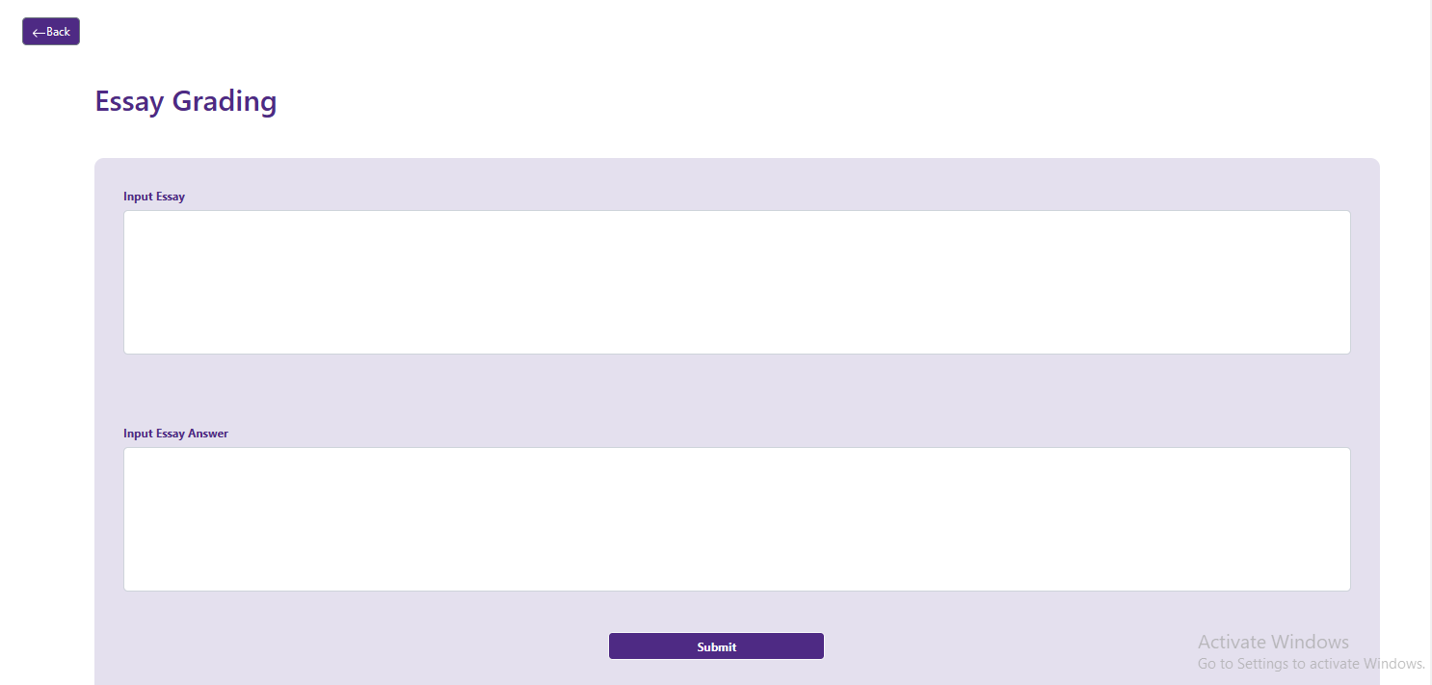

# **Conclusion**

During the course of our first iteration, which spanned over the months of September to October, we successfully completed the objectives we had planned for this duration. These included learning the required new tools and technologies such as Django and React; designing architectural diagrams; defining use cases; scrapping marking schemes and data extraction from online.

# **References**

1. International Computer and Literacy study:

<https://nces.ed.gov/surveys/icils/icils2018/theme1.asp>

1. Google Classroom: [https://classroom.google.com](https://classroom.google.com/)
2. Piazza: <https://piazza.com/>